2023
ORDER OF BUSINESS
& BOOK OF REPORTS

Order of Business and Book of Reports

140th Annual Fall Session

Sunday, October 22, 2023

East Thomaston Baptist Church
Thomaston, Georgia

Rev. Eddie Johnson, Presiding

2023 Officers

Rev. Steve Laughman Associational Mission Strategist
Rev. Eddie Johnson Moderator
Rev. Mark Harris Vice-Moderator
Mrs. Joan German Treasurer
Mrs. Marni Laughman Clerk

Program of the Fall Meeting
Presiding: Eddie Johnson, Moderator

Welcome & Prayer Joey Smith
Call to Order of the 140th Annual Fall Session & Adoption of the Program Eddie Johnson
Recognition of New Ministers/Guests Eddie Johnson
Associational Programs and Miscellaneous Business:
Treasurer Report Joan German
Budget and Finance Committee Ricky Niblett
Nominating Committee & Election of Officers Derrick Keeter
Membership Committee Bob Wilson
Steering Committee Travis Graham
Church Health & Strengthening Travis Graham
Missions & Community Impact Brenda Rutherford
College & Collegiate Ministry Gabe Thomas
Church Planting & Replanting Mark Harris
Associational Mission Strategist Steve Laughman
Worship Service:
Praise & Worship Melanie Chambers & Karen Blevins
Life, Ministry, & Missions Update John, Cheryl, Lillie Jo & Josiah Blackmon

On the Program
Blackmon, John, Cheryl, Lillie Jo, & Josiah Associate Pastor, Calvary International Baptist Church
Blevins, Karen Pianist; Member, East Thomaston
Chambers, Melanie Music Director, Meansville
German, Joan Treasurer; Ministry Assistant & Member, Trinity
Graham, Travis Chairman & Priority Team Leader; Pastor, Valley Grove
Harris, Mark Priority Team Leader; Pastor, Mount Olive
Johnson, Eddie Moderator; Pastor, Macedonia
Keeter, Derrick Pastor, Shiloh Upson
Laughman, Steve Associational Mission Strategist; Elder, The Rock
Niblett, Ricky Chairman; Pastor, Shiloh Lamar
Rutherford, Brenda Priority Team Leader; Member, Fellowship
Smith, Joey Pastor, East Thomaston
Thomas, Gabe Campus Minister; Student Pastor, Maynard
Wilson, Bob Chairman; Pastor, Trinity

FINANCIAL REPORT 2023

Church Receipts January-September 2023

Antioch | 5,328.17
Bethany | 2,666.64
Beulah | 2,095.00
Calvary | 2,126.85
Clark's Chapel | 900.00
Concord | 1,350.00
Culloden | 450.00
East Thomaston | 2,765.20
Elkins Creek | 0.00
Emory's Chapel | 0.00
FBC Barnesville | 16,095.89
FBC Forsyth | 900.00
FBC High Falls | 3,212.45
FBC Thomaston | 8,896.49
Fellowship | 2,037.92
Garden Hill | 0.00
GracePoint | 0.00
Grace Community | 0.00
Hendricks | 1988.00
Jeff Davis | 75.00
King's Chapel | 0.00
Macedonia | 1,350.00
Maynard | 7,359.26
Meansville | 2,250.00
Milner | 3,817.02
Mount Olive | 14,794.55
Mountain View | 20,116.00
Mt. Pleasant | 0.00
Mt. Zion | 0.00
Neal | 450.00
New Bethel | 450.00
New Harmony | 271.20
New Hope Zebulon | 3,166.64
Pritchett Memorial | 1,761.84
Russellville | 778.45
Shiloh Lamar | 2,200.00
Shiloh Upson | 450.00
Silvertown | 919.11
The Rock | 1,618.97
Trinity | 2,700.00
Valley Grove | 3,861.25
Yatesville | 1,575.00
Total Receipts | 120,776.90

CBA Checking, Designated, & Foundation Account Balances September 2023
Colony Checking Account Balance
Beginning Balance |  |  | $83,677.38
Ending Balance |  |  | $83,550.10
Colony Bank general checking account reflects all designated and undesignated funds.
Designated Accounts Income & Expenses
 |  |  | Beginning 9/23 | Income | Expenses | Ending 9/23
Annual Meeting Expenses |  |  | 2,356.97 |  | 123.01 | 2,233.96
Children's Ministry |  |  | 222.75 |  |  | 222.75
Church Planting/Replanting |  |  | 0.00 |  |  | 0.00
Disaster Relief |  |  | 560.00 | 378.55 | 938.55 | 0.00
ESL Program |  |  | 450.32 |  |  | 450.32
Gordon BCM |  |  | 2,174.53 |  | 595.98 | 1,578.55
Men's Ministry |  |  | 205.13 |  |  | 205.13
Outreach Equipment |  |  | 889.37 | 500.00 | 258.65 | 1,130.72
Strategy Planning |  |  | 109.34 |  |  | 109.34
Thailand Missions |  |  | 31,346.41 | 725.00 | 2,000.00 | 30,071.41
Women's Ministry |  |  | 431.81 |  |  | 431.81
Youth Designated Fund |  |  | 4,681.27 | 4,188.00 |  | 8,869.27
Total Designated Accounts |  |  | 43,427.90 | 5,791.55 | 3,916.19 | 45,303.26
Georgia Baptist Foundation Accounts
Market Value
 |  |  | 9/30/2022 | 12/31/2022 | 3/31/2023 | 6/30/2023 | 9/30/2023
Centennial Fund |  |  | 97,210.62 | 105,460.47 | 109,316.18 | 112,760.27 | 108,917.85
Centennial Equipment Fund |  |  | 5,633.47 | 6,111.56 | 6,335.00 | 6,534.59 | 6,311.92
Centennial Cliburn Scholarship Fund |  |  | 10,935.02 | 11,795.28 | 12,193.30 | 12,589.38 | 12,158.22
Centennial Mission Fund |  |  | 14,414.18 | 15,637.47 | 16,209.20 | 16,719.90 | 16,150.15
Total Market Value for GBF Accounts |  |  | 128,193.29 | 139,004.78 | 144,053.68 | 148,604.14 | 143,538.14

Budget & Finance Committee 2023
Ricky Niblett, Chairman

Proposed
Centennial Baptist Association 2023 Budget Jan-Sept Balance 2024 Budget
Operating | 22,525.00 | 26,696.27 | *(4,171.27) | 20,525.00
Personnel | 95,366.74 | 71,214.07 | 24,152.67 | 97,474.23
Ministry | 43,200.00 | 29,872.02 | 12,127.98 | 44,460.00
Church Health & Strengthening | 20,400.00 | 15,783.79 | 4,616.21 | 20,400.00
Missions & Community Impact | 7,600.00 | 3,088.23 | 4,511.77 | 8,000.00
Campus & Collegiate Ministry | 14,000.00 | 11,000.00 | 3,000.00 | 14,860.00
Church Planting & Replanting | 1,200.00 | 0.00 | 1,200.00 | 1,200.00
Total Budget | 161,091.74 | 127,782.36 | 33,309.38 | 162,459.23
*Steering Committee approved a total renovation of parsonage bathroom due to a leak. Total cost $15,530.62.

This budget represents the structure of the association. A more detailed budget is available for anyone who wants specific information. This budget represents a <1% increase over the 2023 budget. Because of the continued faithful giving of the churches and the existence of surplus funds from past years, the Budget & Finance Committee believes we can achieve this faith budget. The following explanation is designed to highlight what went into making this budget.
- Operating expenses include office needs, insurance, pastorium maintenance, and utilities.
- Personnel expenses include salaries and benefits of staff.
- Ministry expenses are divided among the four priorities of the association.
- Proposed changes to the 2024 budget include:
  - A decrease in Operating of $2,000 in property insurance costs due to new policies with different company
  - A 3% cost of living increase for the Associational Mission Strategist and Ministry Assistant.
  - An increase in the Ministry Budget under Missions & Community Impact of $400 to help offset expected increases to costs of Georgia Baptist Mobile Dental Unit.
  - A 3% cost of living increase for the Campus Minister, and an increase of $500 for Gordon College BCM.

2024 Moderator Appointed Committee Members & Nominating Committee Recommendations
Brad Ellington, Chairman

2024 Committees | Term ending | Executive Committee:  Membership: “The Executive committee shall be composed of the pastor of each church, one lay member from each church elected by the church, the Moderator, Vice Moderator, Clerk, Treasurer, Parliamentarian, members of the Steering Committee, all Directors and Committee Chairmen, Associational Missionary, and all full-time staff of member churches.”  Centennial Baptist Association schedules two Executive Committee Meetings every calendar year in February and in September.  *The Steering Committee is made up of 11 members: 4 At-large Members (with rotating terms), 4 Priority Team Leaders, and 3 Chairs of standing committees (Nominating, Membership, Budget & Finance).
Nominating (Appointed by Moderator)
Derrick Keeter (Chair) | 2024
Matthew Bishop | 2025
Joey Smith | 2026
Membership
Bob Wilson (Chair) | 2024
Jeff Yearwood | 2025
Dean Hemphill | 2026
Budget and Finance
Lisa Melton | 2024
Billy Turner | 2025
Cindy Darsey | 2025
Brad Ellington (Chair) | 2026
Jason Mobley | 2026
Steering Committee*
Josh Gilliam (At-large) | 2024
Walter Burgess (At-large) | 2024
Becca McDaniel (At-large) | 2024
Harvey Ellis (At-large) | 2026
Derrick Keeter (Chair Nominating) | 2024
Bob Wilson (Chair Membership) | 2024
Brad Ellington (Chair Nominating) | 2026
Travis Graham (Church Health & Strengthening)
Brenda Rutherford (Missions & Community Impact)
Gabe Thomas (Campus & Collegiate)
Mark Harris (Church Planting & Replanting)
Officers
Moderator | Mark Harris
Vice – Moderator | John Wesley Long
Clerk | Marni Laughman
Parliamentarian | Claude Turner
Treasurer | Joan German
Assistant Treasurer | Ronnie VanHouten
2023 Centennial Calendar
www.centennialbaptistassociation.com/calendar

January
8 GBBI at Centennial classes begin for Spring Semester
11 Steering Committee
29-31 AMS Retreat, Office Closed
February
22 Executive Committee
25-26 GBMB Evangelism Conference, FBC Conyers
March
3-10 Week of Prayer for North American Missions
7-9 Dental Clinic, FBC High Falls
31 Resurrection Sunday
April
TBA Elevate Spring Training Event
1 Application Deadline, Cliburn Scholarship
9 GBBI at Centennial last day of classes for Spring Semester
May
2 National Day of Prayer
7 Steering Committee
June
11-12 Southern Baptist Convention, Annual Meeting, Indianapolis
August
TBA GBMB Spark Conference (Multiple dates and locations)
6 Steering Committee
12 GBBI at Centennial classes begin for Fall Semester
September
Mission Georgia Emphasis
6-8 EQUIP Student Discipleship Weekend
19 Executive Committee
October
13-20 Week of Prayer for Associational Missions
20 Annual Fall Meeting
November
11-12 GBC Annual Meeting
14 Steering Committee
19 GBBI at Centennial last day of classes for Fall Semester
28 Thanksgiving
December
1-8 Week of Prayer for International Missions
3 Ministers and Wives Christmas Dinner
23-31 CBA Office closed for Christmas

All dates and locations are subject to change. Check the monthly newsletter for any updates, additions, or changes. Equipping opportunities such as Roundtables and Learning Communities will be posted on the website calendar and in the newsletter as they are scheduled. Priority Team meetings will be scheduled as needed by each team.
Membership Committee 2023
Bob Wilson, Chairman

It is the responsibility and privilege of the Membership Committee to review applications from churches that express an interest in joining the Centennial Baptist Association. We follow a process which has been previously approved by the association. It requires agreement in three particular areas from applying churches:

- Doctrinal Agreement – Affirmation of the Baptist Faith and Message 2000.
- Missional Commitment – Support of missions both locally and globally.
- Associational Partnership – Participation in the work of the local association.

The process begins with a formal application by the church seeking affiliation. This is followed by an interview where leadership from the church meets with the Membership Committee to get to know one another and to ensure that we are in agreement. The Membership Committee also takes this time to review the church’s documents such as constitution and any doctrinal statements. If both the church and the committee agree that we should move forward, the committee will then recommend the church for membership in the association at one of our annual meetings. If approved, the church will begin a one year period of Watchcare. At the end of the year, as long as there is no reason to the contrary, the church will become a full member of the Centennial Baptist Association.

First Baptist Church of High Falls completed their one year of Watchcare in February of 2023 and is now considered a full member of the association.

Graceview Church in Barnesville has completed the application and interview process. The church and the committee are in agreement to move forward.

The Membership Committee makes the motion that Graceview Church in Barnesville be accepted as a member church of the Centennial Baptist Association, following the established protocol of a one year period of Watchcare.

It has been an honor to get to know the leadership of Graceview and to walk through this process with them. We look forward to many years of partnership with them. Graceview Church meets in the facilities formerly occupied by Pineview Baptist Church, a long-standing member of this association.

After nearly 5 ½ years as a member of Centennial Association, GracePoint Church of Thomaston recently voted to dissolve as a church. We are thankful for the lives that were impacted for the Gospel by this church.

Steering Committee 2023
Travis Graham, Chairman

Part of the restructuring of the association was to include Committee Chairs and Priority Team Leaders on the Steering Committee to better facilitate communication between the various ministries of the association. This new model has worked well for us. Here are the major items of business for the year:
- Officers for the year are Travis Graham, Chairman, and Josh Gilliam, Vice-Chairman.
- Parsonage Bathroom Renovation. Due to a problem with the subfloor near the shower, there was a need to either repair or renovate one of the bathrooms at the parsonage. We chose to go with a total renovation and to fund this from the general fund. The total cost of the renovation was approximately $15,000.
- Cliburn Scholarship. Unfortunately, there were no applicants for the Cliburn Scholarship this year, so we were unable to award anyone in 2023. We know that there are several people in our association who are pursuing a seminary degree at this time, so we would like to remind you to apply by April 1, 2024.
- Property Insurance. Due to rising premiums from our previous insurance company, we authorized the AMS to explore other options. This resulted in a savings of about $2,000 annually.
- Church Planting and Replanting Budget. Based on the fact that this is a new ministry which was unable to use the funds allocated to them this year, the committee voted to move any remaining budgeted funds to a designated account at the end of the year to be available for use in subsequent years.
- Thailand Missions. The Missions and Community Impact Team recommended that we increase the regular monthly contribution sent to support the Blackmons from $1000 to $2000 per month beginning in August 2023. Support from churches and individuals has been consistently above what was needed to continue sending this amount. The Blackmons’ support from the Hawaii Pacific Convention in the amount of $1000 per month was set to end, so it made sense to increase the amount to make up for that amount. This recommendation was approved by the Steering Committee.

Church Health & Strengthening 2023
Respectfully Submitted by: Travis Graham

Over the last year, our Team has worked at making Centennial Churches stronger and healthier through a variety of efforts. Here are a few of the avenues we used to help fulfill this purpose:
- 2023 Spring Meeting - This past Spring our association focused on "Campus and Collegiate Ministries." Gabe Thomas secured a wonderful lineup of speakers for us, which both encouraged and challenged us to focus more on reaching collegiate students and young adults.
- Discipleship Learning Communities - Discipleship Learning Communities have been meeting since January. This group roundtable is designed to help churches better understand the purpose of and how best to develop ways of intentional discipleship.
- Equip - In September, FBC Barnesville hosted our annual Equip Conference for students. This year's theme was "Called." Around 250 students and adults attended the event over Friday and Saturday, with over 20 students responding for salvation or a call to ministry.
- Called Cohorts - In response to the number of students who expressed a desire to explore a call to ministry at Equip 2023, "Called Cohorts" were created. These Cohorts will be led by Associational Pastors. The Cohort leaders will meet with their students via Zoom to help them walk through what a call to ministry looks like in today's world.
Looking Forward
- Georgia Baptist Bible Institute (GBBI) through Brewton Parker College - Our association is excited about the opportunity to partner with Brewton-Parker College to offer College Classes through our local association. The classes will be college level and will be offered in both "for-credit" and "non-credit" options. The "for-credit" classes will directly transfer to Brewton-Parker where a student could further their degree program. Registration is open NOW! You can register through the link provided on the Centennial Baptist Association website. Classes begin January 8, 2024. We will be offering two classes in the Spring Semester, Introduction to the Old Testament and Biblical Worldview.
- 2024 Spring Meeting - The 2024 Spring Meeting will focus on caring well in the local church. We will learn how we can provide soul care for those in our ministries.
Missions & Community Impact 2023
Respectfully Submitted by: Brenda Rutherford, Chairman

The Missions and Community Impact Team met on February 9, April 13, and August 10. The current team members are Dr. Tommy Farr, Ruth Hatchett, Ted Kandler, Brenda Rutherford, and Julie Smith.
- The team approved the use of $3600 of the Mission and Community Impact budget for the repair or replacement of items in the outreach trailer and the purchase of a new inflatable slide.
- The team approved to support New Mercies Biblical Counseling with $1200.
- The team approved to support United, an evangelical worship service held in Upson County, on August 11, 2023, with $300.
- The Dental Health Clinic was held on March 9-11, 2023, at First Baptist Church, Thomaston. Sixty-four patients were treated. Twenty-eight volunteers were involved in this 3 day ministry. The services provided saved patients an estimated total of $70,000 of dental care. The next Dental Health Clinic is scheduled for March 7-9, 2024, at High Falls Baptist Church.
- The team is seeking a volunteer to promote foster care in the association.
- The team is thankful for the support demonstrated by the churches for the CBA partnership with the Blackmon family.

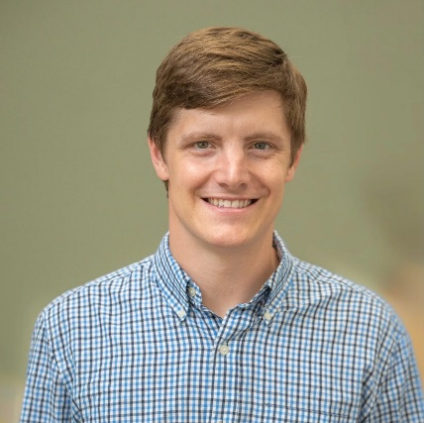
Campus and Collegiate Ministries REPORT 2023
Respectfully Submitted by: Gabe Thomas

This past year has been an exciting time on the campus of Gordon State College. In May, the topic of the yearly Elevate Church Strengthening Conference was Collegiate Ministry. Church members from every corner of the Association showed up on Sunday night to hear how we can better reach college students and prepare our high schoolers to follow Jesus when they go off to college. That Monday, our association was once again well represented as our friends from the Great Exchange came out and led us in giving spiritual surveys to students as a means of sharing the gospel. The gospel was shared with over 60 students (which is roughly 2% of the Gordon State Campus) and there were four professions of faith.

During the summer we were given an opportunity by Gordon State College to be a part of their new student orientation. Not only were we able to set up a booth for students to see when they arrived for orientation. We were given the opportunity to participate in the session where students learned about what student organizations were present on campus. The college invited us to come and tell students about BCM. Many of the new students we have involved in BCM this semester are here because of the connection we made at orientation.

While we understand our ministry is not all about numbers, we will not fail to celebrate an increase in students involved in our ministry. Our bi-weekly Monday night worship gatherings have gone from having less than 20 students present to averaging between 30 and 40 students present. Our weekly Bible Study has gone from averaging five to six students, to averaging 13-14. We can report, as can BCMs all across our state, that God is doing big things in our ministry. This past week we held our first Great Exchange of the Semester. We celebrate the five professions of faith that were made.

Next year, our focus will begin to become more missions focused. Our plan is to go to spend Spring Break serving in Brooklyn, New York. I want students to see how ministry looks in an unchurched context. Who knows, this could be the place a student begins to feel a call to missions or ministry. Part of our budget for next year is intended to help lower the cost of that trip for students. We are also going to begin to place a stronger emphasis on discipleship. The goal is to have smaller separate Bible studies for men and women. We also hope to expand our leadership team. We are able to do this because we have more students coming to BCM events. But it is not just for the Gordon State BCM. A part of doing ministry at Gordon is knowing that people will transfer to other schools. Our goal is to help students ready to be leaders at the BCM at whatever college or university they transfer to.

Church Planting and Replanting
Mark Harris, Chairman

We are thankful that the Association sees the need to be prepared when there is an opportunity for church planting or replanting in our area. This is still very new to us, so this year was spent preparing ourselves. Priority Team Leader Mark Harris attended the Replant Summit of the North American Mission Board to receive training. The Steering Committee agreed with a recommendation to move any unused budgeted funds into a designated account for Church Planting and Replanting.

The association’s most recent effort in the area of replanting is The Rock Church which recently celebrated four years since the restart. The Rock Church continues to grow and demonstrates the value of investing in replanting of churches that are struggling. The process of replanting The Rock Church required a combined effort and support from several of our Centennial churches, and it served as the catalyst for the formation of this priority team.

If your church would like to know more about what it means to replant or plant a church, please contact Mark Harris at Mount Olive Baptist Church or the CBA office.

ASSOCIATIONAL MISSION STRATEGIST REPORT 2022
Respectfully Submitted by: Steve Laughman
http://www.centennialbaptistassociation.com/blog

Thank you for trusting me. Last year at this meeting, you voted to restructure our association, to increase our budget by about 12%, and to bring on a new staff member. I am thankful that the churches of this association were willing to make these big decisions, and I understand that many of you based those decisions on your trust that I was following God’s leadership regarding the direction of our association. The success of this partnership we call the Centennial Baptist Association does not rest on any one individual but on the collective effort of over 40 churches as we are empowered and led by the Spirit of God. In light of that truth, I am pleased to report that each of those decisions has produced fruit for the Kingdom.

It is not my intention to reiterate what the Priority Teams will report on their own. However, I want to highlight the fact that adjusting to a team approach has been smooth and productive. Each team has accomplished goals this year and the future is bright. Now that we have successfully transitioned, the teams are becoming more efficient. Some are still working toward becoming what they will become, while others have found their groove. If you or someone in your church has a desire to be on one of our Priority Teams, please let us know so we can connect them with the right individuals.

Many churches struggle to find qualified candidates to serve in leadership roles such as pastor, music, and youth. While I am thankful for all who are currently serving and for those who have served our churches in the past, I am also aware that we have a responsibility to raise up and equip leaders to fill those roles in the future. We talk about having a “development mentality versus a recruitment mentality.” This simply means that it is wise to disciple people in such a way that when a need exists, we can look within our churches rather than looking somewhere else. This year we have sought to be proactive and intentional about how we do this.

It takes time to raise up men and women capable of serving in these ministry roles. That is why we invest in ministries related to equipping the next generation. The theme this year for EQUIP, our student discipleship weekend, was “Called.” Twenty-one students from middle school to young adults expressed a desire to explore God’s call to vocational ministry. We have assigned each of these young people to a Called Cohort where they will work with a mentor for the next year to prepare for ministry. If you know a student who wants to be part of a Called Cohort, make sure they reach out to us so we can include them in this process.

Baptist Collegiate Ministries is another way we are equipping the next generation for ministry. We understand that many of the college students involved in BCM will serve the Lord through their chosen vocation, and we want them to be prepared to do that well. We also know that some will be called to vocational ministry and will go on to serve churches here in Centennial and in other places around the world. In fact, several of our current pastors and staff members were part of the BCM at Gordon or on other campuses. BCM provides an environment where students can learn and serve the Lord as they prepare for what God has planned for them.

We are very excited about our new partnership with the Temple Baptist Theological Seminary and Brewton Parker College. Beginning in January of 2024 we will be offering in-person college level classes right here in Centennial. First Baptist Barnesville will host the classes which will be taught by qualified instructors from within our association. Students can earn up to 27 hours of credit toward an associate or bachelor’s degree. The purpose of these classes is to provide biblical instruction for anyone who wants to be better prepared for ministry. Classes are open to pastors, staff members, Sunday School teachers, and anyone who has a desire to learn. If you want to be included in the January classes, now is the time to apply and register. Contact the CBA office or look on our website for more information.

Along with the desire to raise up leaders, I also believe we have a responsibility to help current pastors and church staff members serve well. Because the task is important and the workers are often few, these church leaders work long hours, balancing the responsibilities of ministry, family, and often a secular job. Let me take a moment to speak to those of you who are not the pastor or on staff at your church. It is in the best interest of your church for your pastor and staff members to take regular, intentional times of rest and renewal. I want to help you make sure this happens and that when it does, it is beneficial for both you and your ministerial staff. I have collected and compiled resources that are now on our website under the heading “Ministry Renewal Leave.” I would love to meet with your leadership to help your church establish a policy that benefits both your church and your ministerial staff.

Marni and I are blessed to serve such a wonderful association of churches. Thank you for your prayers for us and your support for what God has called us to do. We are here to serve you, so please give us that opportunity when you have a need.

Church/Association | Mailing Address | City | Zip | Office # | Pastor/ AMS | Email Address | Phone #
Centennial Baptist Association | PO BOX 210 | Thomaston | 30286 | 706-647-4959 | Steve Laughman | cbaamsteve@gmail.com | 770-314-6107
Antioch Baptist Church | 2269 Barnesville Road | Yatesville | 31097 | 706-472-3373 | Garth Forster, INT | garthf235@gmail.com | 770-584-2051
Bethany Baptist Church | PO BOX 539 | Bolingbroke | 31004 | 478-974-0002 | Jimmy Corbitt | james.corbitt@cox.net | 478-474-6252
Beulah Baptist Church | 7327 GA-109 | Molena | 30258 |  | Jim Pitts | jpitts2636@bellsouth.net | 770-4687658
Calvary Baptist Church | 640 Rose Avenue | Barnesville | 30204 | 770-358-1208 | Allen Newman | anewman517@bellsouth.net | 678-588-3323
Clark's Chapel Baptist Church | 176 Mathis Lake Road | Thomaston | 30286 | 706-647-6169 | Dean Hemphill | phemphill@windstream.net | 706-647-2209
Concord Baptist Church | PO BOX 181 | Concord | 30206 | 770-884-5205 | Jeff Yearwood | jeff.yearwood@fnf.com | 770-330-0063
Culloden Baptist Church | 47 Church Street | Culloden | 31016 |  | Albert Parker | albert@pstel.net | 478-885-2575
East Thomaston Baptist Church | PO BOX 329 | Thomaston | 30286 | 706-647-3702 | Joey Smith | joeyes@windstream.net | 706-647-0388
Elkins Creek Baptist Church | 7504 GA HWY 74 | Molena | 30258 |  | Tim South | timothylsouth@yahoo.com | 478-952-2117
Emory's Chapel Baptist Church | 2 Emory Chapel Road | Thomaston | 30286 |  | David Dawson | wdawson68@msn.com | 770-584-9778
FBC Barnesville | 200 Zebulon Street | Barnesville | 30204 | 770-358-2353 | Jason Teal | wjteal@gmail.com | 912-978-1449
FBC Forsyth | 95 W Morse Street | Forsyth | 31029 | 478-994-5240 | Hambrick Brooks | hambricbrooks@gmail.com | 404-867-9083
FBC High Falls | 4408 High Falls Road | Jackson | 30233 | 478-994-1653 | Jim Milirons, INT | missiologist1@gmail.com | 404-944-6813
FBC Thomaston | 208 S Church Street | Thomaston | 30286 | 706-647-7889 | Bryan McPherson | tbmfish@gmail.com | 478-733-2386
Fellowship Baptist Church | 1165 Hannah's Mill Road | Thomaston | 30286 | 706-648-6521 | Jason Weeks | jweeks0328@yahoo.com | 678-492-2185
Garden Hill Baptist Church | 88 Vining Street | Forsyth | 31029 | 478-994-4499 | Bill Thigpin | btjt@csranet.net | 478-521-0205
Grace Community Baptist Church | PO BOX 265 | Molena | 30258 |  | Terry Murphey | murpheyc1@bellsouth.net | 678-876-9778
Hendricks Baptist Church | 2233 Hendricks Church Rd | Thomaston | 30286 |  | Jason Weems | jaweems@upson.k12.ga.us | 706-975-9325
Jeff Davis Baptist Church | 236 Jeff Davis Road | Thomaston | 30286 |  | Milton Hill | circitrider08@yahoo.com | 706-656-4877
King's Chapel Baptist Church | 884 Jeff Davis Road | Thomaston | 30286 | 706-472-3228 | Eddie Mathews | efmathews@yahoo.com | 706-975-7130
Macedonia Baptist Church | 512 Hightower Street | Thomaston | 30286 |  | Eddie Johnson | ejsr57@gmail.com | 478-960-0389
Maynard Baptist Church | PO BOX 576 | Forsyth | 31029 | 478-994-2120 | Matthew Bishop | matthewbishop@maynardbc.com | 478-538-3028
Meansville Baptist Church | PO BOX 239 | Meansville | 30256 | 770-567-3834
Milner Baptist Church | 107 Pecan Drive | Milner | 30257 | 770-358-2954 | Brad Ellington | wbellington2321@gmail.com | 912-294-1711
Mount Olive Baptist Church | PO BOX 43 | Molena | 30258 | 770-884-5327 | Mark Harris | mark@movingoutboldly.org | 770-584-5109
Mount Pleasant Baptist Church | 1016 Spear Road | Forsyth | 31029 | 478-994-7036 | William Kirkland |  | 478-394-3014
Mount Zion Baptist Church | 129 Hillview Drive | Thomaston | 30286 | 706-975-1410 | Stephen Morgan | stephenmorgan01.sm@gmail.com
Mountain View Baptist Church | 2569 Jeff Davis Road | Thomaston | 30286 | 706-648-6224 | Ryan Christopher | thechristopers@yahoo.com | 770-584-0547
Neal Baptist Church | PO BOX 149 | Concord | 30206 |  | Ken English | bro_ken_english@yahoo.com | 706-975-1410
New Bethel Baptist Church | 1278 Jeff Davis Road | Thomaston | 30286 |  | Claude Turner | claudewturner@charter.net | 706-975-8844
New Harmony Baptist Church | 163 New Harmony Church Rd | Thomaston | 30286 | 706-647-5848 | Tim Bosworth | hoosierdaddy3758@gmail.com | 706-741-3758
New Hope Baptist Church | 4920 New Hope Road | Zebulon | 30295 |  | Josh Gilliam | josh.gilliam@southernwise.com | 770-584-2168
Pritchett Memorial Baptist Church | 496 Jugtown Road | Meansville | 30256 | 706-648-3578 | Rick Rose | mhcowkiller@yahoo.com | 706-741-4312
Russellville Baptist Church | PO BOX 6004 | Forsyth | 31029 |  | Bill Wilson | williamlorenwilson@gmail.com | 904-614-4338
Shiloh Lamar Baptist Church | 1530 HWY 41 S | Barnesville | 30204 | 770-358-7390 | Ricky Niblett | niblettrichardl@bellsouth.net | 770-825-2586
Shiloh Upson Baptist Church | 2737 HWY 19 N | Thomaston | 30286 | 706-648-3550 | Derrick Keeter | derrickkeeter@hotmail.com | 678-898-9864
Silvertown Baptist Church | 300 Goodrich Avenue | Thomaston | 30286 | 706-647-4844 | Paul Caspers | pecaspers@gmail.com | 205-706-7166
The Rock Church | PO BOX 82 | The Rock | 30285 |  | Wesley Lassiter | pastor@therockchurchga.com | 772-559-4978
Trinity Baptist Church | 410 S Church Street | Thomaston | 30286 | 706-647-4234 | Bob Wilson | bob@trinitysbc.org | 706-601-0034
Valley Grove Baptist Church | 1372 Atwater Road | Thomaston | 30286 | 706-648-2328 | Travis Graham | tgraham102@gmail.com | 478-396-3990
Yatesville Baptist Church | 59 College Street | Yatesville | 31097 |  | John Wesley Long | johnwlong4@gmail.com | 706-975-7331

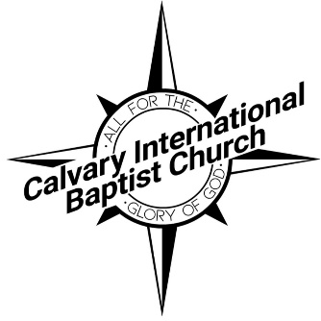

ขอบคุณครับ/ค่ะ (kawp khun krub/ka) THANK YOU!!! We could never fully express our thanksgiving to God for the Centennial Baptist Association and the generosity of churches and individuals that have made it possible for us to follow the Lord’s call for the initial phase of ministry and mission in our international setting in Bangkok, Thailand at Calvary International Baptist Church. Through your prayers and gifts, you daily partner with us to serve in one of the least-reached major cities of the world. It is a privilege to be “your” missionaries as we serve our Great God and work to fulfill His commission on the far field. – The Blackmons

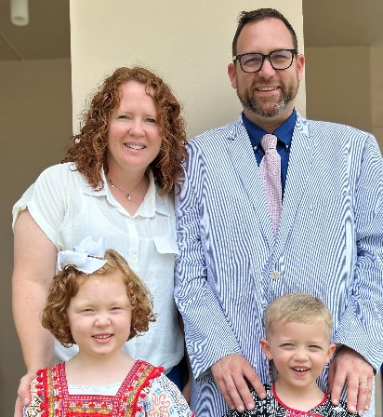
Pursue the well-being of the city I have deported you to. Pray to the Lord on its behalf, for when it thrives, you will thrive.” – Jeremiah 29:4-7

“[M]any in the missionary force suffer a double culture shock. . . they must not only relate to a second culture and language, but they must make the transition from childhood rural patterns to urban life overseas. Yet missionaries, as all God’s people, must come to grips with the challenge of the city…Can Southern Baptists not settle down in the city, learn to love it, and seek its highest welfare, feeling that God has placed us there? If we are to make an impact on the city, we must ‘set our faces toward’ it as Jesus did and be willing to take up our crosses and die with him there. Since the Bible says we have and urban future and since the cities are so crucial in carrying out the Great Commission, can we not learn to be God’s people in the urban world of our day?” (Ron Hill, Bangkok: An Urban Arena, Convention Press, 1980, pp. 21-22).

“God loves cities because there are people in cities and He loves people.” – Timothy Keller

Should I not care about the great city of Nineveh, which has more than 120,000 people who cannot distinguish between their right and their left, as well as many animals?" – Jonah 4:11

- It really doesn’t matter if we love or like Bangkok, God loves Bangkok. By that, we mean He loves the peoples of Bangkok.

“The gospel alone can give us the humility (“I have much to learn from the city”), the confidence (“I have much to give to the city”), and the courage (“I have nothing to fear from the city”) to do effective ministry that honors God and blesses others.” – Timothy Keller, Center Church

World population in cities: Today, over 56% of the world’s population lives in cities like ours. By 2050, it is projected that 7 out of every 10 people (70%) will live in cities.

The Christian population of Thailand (and Bangkok) is no more than 1.1 %

Metro-Bangkok: 15 million people.

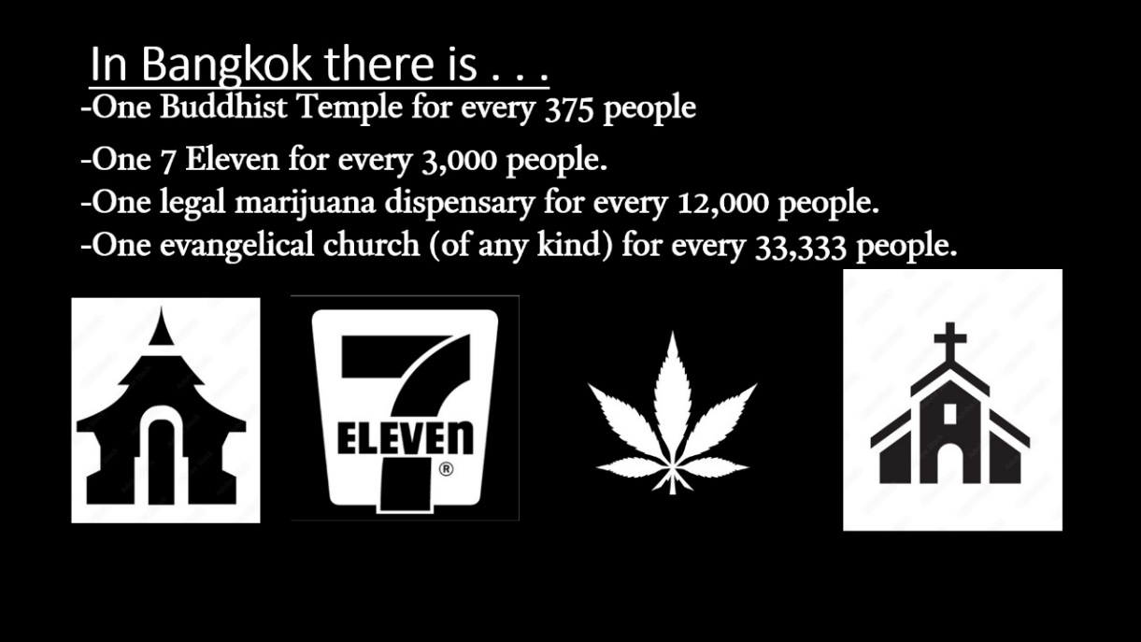

Highlights:
- Weekly ministry
  - International and language services
  - Bible study and discipleship
  - Partnerships and opportunity for outreach

- Benevolence/Refugee ministry
  - Partnership with Send Relief
  - Food distribution
  - GED studies

- Gateway ministry
  - Church planting, other areas of Thailand
  - Nepal
  - People groups, nationalities, and ethnicities to the ends of the earth
Ways to pray for the Blackmons:
- Physical, Mental, Spiritual Health
- Friendships and encouragement
- Opportunities to share the Gospel (especially in our personal lives)
- Clarity for this transition year

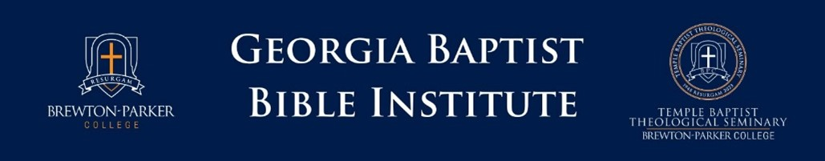

The Georgia Baptist Bible Institute of Brewton-Parker College is a collaborative effort with the local Baptist Associations which provides Biblical and Ministry training for pastors or lay persons who desire to increase their effectiveness in ministry and pursue a college education.

Faithfully Providing Ministry Training – committed to the BFM2000.  - The program is designed to support pastors and churches.  - Courses are geared toward ministry training.  - Professors are serving in ministry and are approved by Brewton-Parker College.  Affordable and Accessible – committed to making ministry training affordable and flexible.  - Semester length courses  - Courses are all in-seat at a local site.  - $150 per course (with one-time application and registration fees.)  - Fully accredited college credit – up to 27 credit hours | Admission Requirements:  - Designed for the non-traditional or returning student.  - A high school diploma or equivalent transcript must be sent to BPC.  Current Classes for Centennial:  - CHR 100 Intro to Christian Worldview  - CHR 101 Intro to Old Testament  - Classes begin January 8, 2024  - Location: First Baptist Church, Barnesville  How to Apply and Register:  - Apply online for the GBBI program at apply.gbbi.bpc.edu  - Once you have applied, you can register for your class online or by using the form provided by your instructor.

Courses provided by Temple Baptist Theological Seminary of Brewton-Parker College
Biblically Based—Ministry Focused
Apply Now: apply.GBBI.bpc.edu
More information available at centennialbaptistassociation.com/registration

